**Jcarl Industry**

Project Members:

Encarnacion, Pia Melissa M.

Flavier, Javier Teodoro E.

Samaco, Japheth Duane C.

Santos, John Michael B.

Zambales, Joshua S.

October 18, 2014

Table of Contents

1 Statement of work 3

2 DATA FLOW DIAGRAMS 5

2.1 DFD Level 0 5

2.2 DFD Level 2 5

2.3 DFD Level 3 6

3 Entity-Relationship Model 7

4 Use Case Diagram 8

Approvals 9

USE CASES 10

4.1 Use Case List 10

4.2 Project Processing 9

4.2.1 Create Project 9

4.2.2 Supplier Quotation 10

4.2.3 Project View 12

4.3 Quotation Processing 13

4.3.1 Material Costing 13

4.3.2 Labor Costing 14

4.4 Supplies Processing 15

4.4.1 Processing to warehouse inventory 15

4.5 Employee Management 16

4.5.1 Salary Computation 16

5 Business Rules 17

6 Data Dictionary 19

6.1 Project Table 19

6.2 Employee Table 19

6.3 Supplier Table 19

6.4 Material Table 20

6.5 Material Usage Table 20

6.6 Purchase Order Table 20

6.7 Payroll Table 21

7 Source code & Readme 21

**Jcarl Industry**

Statement of Work

Prepared: October 17, 2014

**Project Name:** Construction Supplies and Services Tracking System

**Project Managers:** Zambales, Flavier, Encarnacion, Samaco, Santos

**Customer:** Jcarl Industry

Project Projected Starting Date of Completion: ____________________________________

**Project Description:**

An Information System, following the Systems Development Life Cycle, will be constructed for the client. The system will manage purchase orders and quotations made between the clients and the suppliers and will also oversee the materials being used by the warehouse personnel for their projects. Working hours of the employees will also be monitored.

**Goal**

This project will implement a tracking system for the industry. The purpose of this tracking is to oversee material transactions between clients and suppliers, organize inventory of the materials being used by the industry. It will also be used to manage employee work hours for the payrolls of the workers. The system will minimize the errors in recording the quotations and orders being made, as well as storing the information and, in addition, making it easier and faster to access. It will make the tracking of material quantities and employee hours easier, and create faster and more accurate computations.

**Objectives**

The system aims to achieve the following:

* record and store data from purchase orders and quotations
* provides an easier and faster retrieval of these data
* minimize the errors in recording data
* easier and faster tracking of material quantities and employee work hours

**Phases of Work**

Deliverables for the Project:

1. Data Flow Diagrams of the Tracking Systems
2. Use Cases Identification
3. Entity-Relation Diagrams showing the connection of tables for the System

Implementation:

* GUI Application for the System
* Installation of the needed JDBC and MySQL drivers and installers
* SQL Database Software installation on required computers
* Using SQL commands on the GUI by buttons provided

# Resume

**Staff Estimates:**

***Name****:* Japheth Duane Samaco

***Position****:* Secretariat, Database Programmer

***Man-hours per day/week****:* 1 hour during weekdays, 2 hours during weekends

***Resume****:* Experience with database systems, web development and programming in general for Java, Python, SQL and Basic C++. Also efficient with human resources, public relations and communications

***Name****:* John Michael Santos

***Position****:* Program Tester, Project Manager

***Man-hours per day/week****:* 1 hour during weekdays, 4 hours during weekends

***Resume:*** Made the deliverables and documentation of CS 122 Project, knows Java, SQL, Basic C++. Efficient in meeting deadlines and initiating group meetings

***Name:*** Joshua Zambales

***Position:***Programmer, Public Relations Officer

***Man-hours per day/week:***1-2 hours per weekday( 3-4 on saturdays)

***Resume:*** One of the developers and analysts of CS 122 project, knows Java, Python, SQL.

***Name:*** Javy Flavier

***Position:***Programmer, Systems Analyst

***Man-hours per day/week:***4 hours on weekdays, 4 hours on weekends

***Resume:***Knows Java, Python, and SQL. Created an inventory for CS 110 and a

database for CS 122.

***Name:*** Pia Encarnacion

***Position:***Programmer, Database Programmer

***Man-hours per day/week:***1 hour per weekday, 4 hours on weekends

***Resume:***one of the developers for CS 122 Project: Flying Donkey Courier Services, one of the creators of CS 119.3 project: Student Helper, knows Java, Python, SQL, basic HTML/CSS, PHP, and Android Programming

# 

# DATA FLOW DIAGRAMS

## DFD Level 0

## C:\Users\Japheth Samaco\Desktop\New folder\DFD Level 0.jpg

## DFD Level 2

## C:\Users\Japheth Samaco\Desktop\New folder\DFD Level 1.jpg

## DFD Level 3

## C:\Users\Japheth Samaco\Desktop\New folder\DFD Level 2.jpg

# Entity-Relationship Model

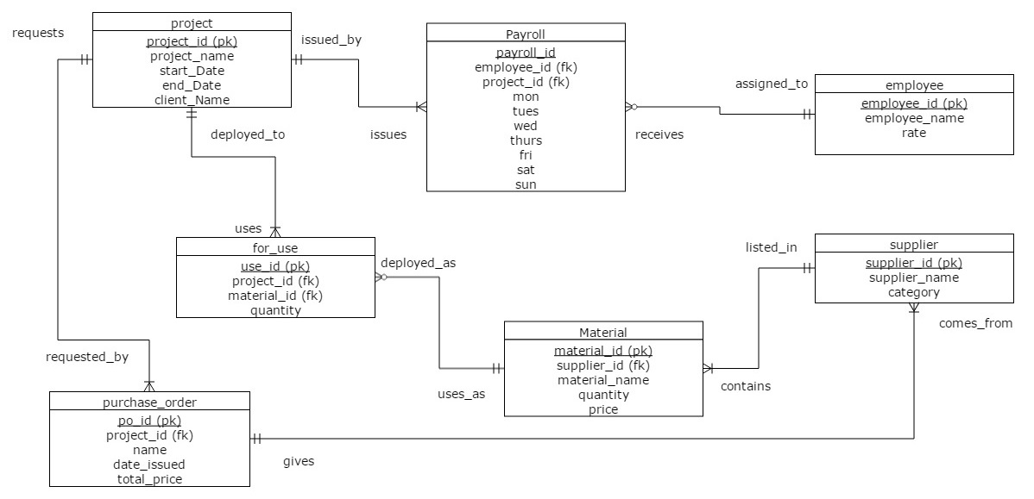

# Use Case Diagram

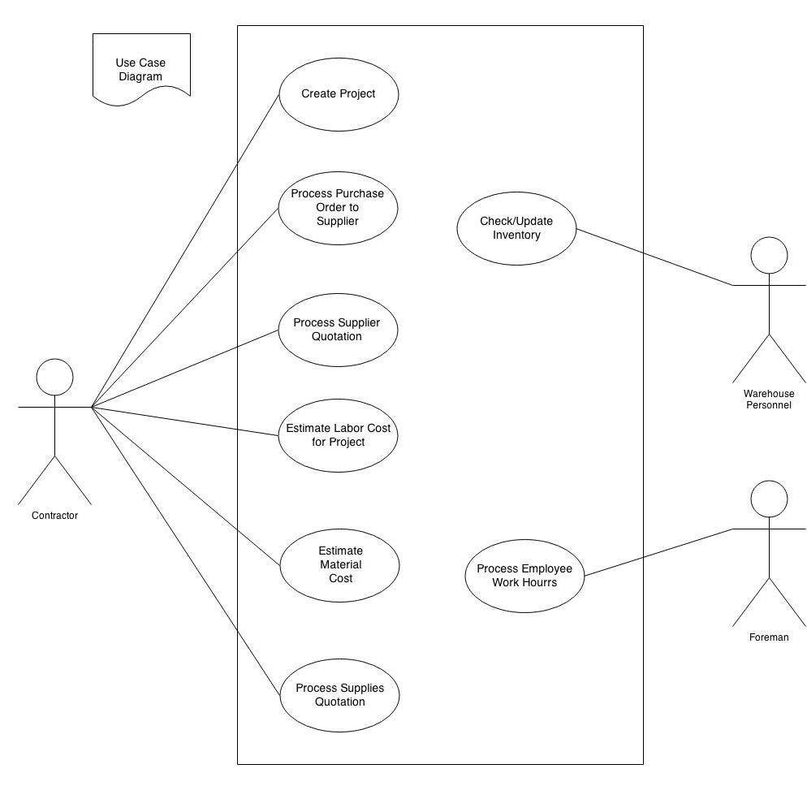

# Approvals

We have carefully assessed the Use Cases for this project. This document has been completed in accordance with the requirements of the System Development Methodology.

MANAGEMENT CERTIFICATION

______ the document is accepted.

______ the document is accepted pending the changes noted.

______ the document is not accepted.

We fully accept the changes as needed improvements and authorize initiation of work to proceed. Based on our authority and judgment, the continued operation of this system is authorized.

Joshua Zambales October 18, 2014

John Michael Santos October 18, 2014

Pia Encarnacion October 18, 2014

Japheth Samaco October 18, 2014

Javier Flavier October 18, 2014

# 

# USE CASES

## Use Case List

|  |  |  |
| --- | --- | --- |
| **Use Case ID** | **Primary Actor** | **Use Cases** |
| 1.1 | Contractor | Create Project |
| 1.2 | Contractor | Supplier Quotation |
| 1.3 | Contractor | Project View |
| 2.1 | Contractor (User or Admin) | Material Costing |
| 2.2 | Contractor (User or Admin) | Labor Costing |
| 4.1 | Foreman | Salary Computation |

## Project Processing

### Create Project

|  |  |  |  |  |
| --- | --- | --- | --- | --- |
| **Use Case ID:** | 1.1 | | | |
| **Use Case Name:** | Create Project | | | |
| **Created By:** | Joshua Zambales | | **Last Updated By:** | Joshua Zambales |
| **Date Created:** | August 10, 2014 | | **Last Revision Date:** | August 10, 2014 |
| **Actors:** | | Contractor | | |
| **Description:** | | User wants to create a project in a system. | | |
| **Trigger:** | | Contract between client and contractor | | |
| **Preconditions:** | | N/A | | |
| **Postconditions:** | | 1. User created a project 2. Project is ready to be continuously updated until accomplishment | | |
| **Normal Flow:** | | [Provide a detailed description of the user actions and system responses that will take place during execution of the use case under **normal, expected** conditions. This dialog sequence will ultimately lead to accomplishing the goal stated in the use case name and description.   1. User chooses “create project” 2. User enters project information (name, date start, date finished(estimate), description, employees to be deployed, materials needed. 3. System validates if project name is already used 4. System displays success message | | |
| **Alternative Flows:**  **[Alternative Flow 1 – Not in Network]** | | 2a. In step 4 of the normal flow, if the customer is not in the bank network   1. System will prompt customer to accept network fee 2. Customer accepts 3. Use Case resumes on step 5 Note: Insert a new row for each distinctive alternative flow. | | |
| **Exceptions:** | | 2a. In step 2 of the normal flow, if the customer enters an invalid input   1. Creation is disapproved 2. Message to customer to re-enter correct input in field 3. Customer enters correct input 4. Use Case resumes on step 3 of normal flow   2b. In step 2 of the normal flow, the customer enters an existing project name   1. Creation is disapproved 2. Message to customer to re-enter another project name 3. Customer enters correct input 4. Use case resumes on step 3 of normal flow | | |

### Supplier Quotation

|  |  |  |  |  |
| --- | --- | --- | --- | --- |
| **Use Case ID:** | 1.2 | | | |
| **Use Case Name:** | Supplier Quotation | | | |
| **Created By:** | Pia Encarnacion | | **Last Updated By:** | August 11, 2014 |
| **Date Created:** | August 11, 2014 | | **Last Revision Date:** |  |
| **Actors:** | | Contractor | | |
| **Description:** | | Once the quotation of all materials from a supplier is received, the information of the items and of the supplier will be processed into usable data. | | |
| **Trigger:** | | Request quotation from supplier | | |
| **Preconditions:** | | 1. Contract has contacted supplier 2. Contractor has received the quotation from the supplier | | |
| **Postconditions:** | | 1. The system will contain data of the materials of a certain supplier based on the quotation 2. Data is organized and detailed 3. Data can be accessed for project processing 4. Supplier is assigned to a project based on the requirements of that project 5. Total cost of materials of a project will be computed | | |
| **Normal Flow:** | | 1. Contractor contacts supplier and requests a quotation of materials 2. Contractor inputs details of the supplier into the system 3. Contractor inputs all the details of each material (like price and quantity) into the system 4. System will assign the supplier to a project //does the system do this? 5. System processes all the data required for a project (including total cost) | | |
| **Alternative Flows:** | | 2a. If the supplier is already part of the database   * + - 1. System will prompt the user that the supplier has been recorded before       2. System will show the details and all the data from the aforementioned supplier       3. Contractor adds information of new materials       4. Use Case resumes on step 4   2b. If the supplier is already part of the database   1. System will prompt the user that the supplier has been recorded before 2. System will show the details and all the data from the aforementioned supplier 3. Contractor updates information of materials 4. Use Case resumes on step 4   2c. If the supplier is already part of the database   * + - 1. System will prompt the user that the supplier has been recorded before       2. System will show the details and all the data from the aforementioned supplier       3. Contractor updates information of supplier  1. Use Case resumes on step 4   3a. If the material is already part of the database   * + - 1. System will prompt the user that the material has been recorded before       2. System will show the details and all the data from the aforementioned material       3. Contractor updates information of the material       4. Use Case resumes on step 4   4a. If the supplier cannot be matched with a project   1. System will still keep the data about the supplier 2. These data will be used for future use 3. Project will continue to find a supplier; repeat Use Case beginning with step 1 | | |
| **Exceptions:** | | 3a. In step 3 of the normal flow, if the price contains non-numerical values   1. System will prompt the user 2. User inputs proper price value | | |
| **Includes:** | | Supplier, 2.1 Material Costing | | |
| **Frequency of Use:** | | Once, when the project will be created, or if the contractor should require more supplies | | |
| **Special Requirements:** | | - | | |
| **Assumptions:** | | 1. Prices are in Philippine Peso or in U.S. dollars  2. Measurements follow the metric system | | |
| **Notes and Issues:** | | - | | |

### Project View

|  |  |  |  |  |
| --- | --- | --- | --- | --- |
| **Use Case ID:** | 1.3 | | | |
| **Use Case Name:** | Manpower Management | | | |
| **Created By:** | Pet Samaco | | **Last Updated By:** | 08/12/14 |
| **Date Created:** | 08/12/14 | | **Last Revision Date:** | 08/12/14 |
| **Actors:** | | Contractor, Admin | | |
| **Description:** | | Presents information of the employee, including currently deployed jobs of the person | | |
| **Trigger:** | | User hits the “”Manpower Management” button | | |
| **Preconditions:** | | 1) Project must have Information of the needed employees to be deployed to the project | | |
| **Postconditions:** | | * + - * 1. System leaves the Manpower Management Tab         2. Information will also be sent to the employee management team, where they may compute the salary of the employees | | |
| **Normal Flow:** | | 1. User inputs the ID of the employee 2. System shows the information on the employee | | |
| **Alternative Flows:** | | N/A | | |
| **Exceptions:** | | 1.a User inputs an invalid employee ID  1. Error message is shown  2. User is brought back to previous window | | |
| **Includes:** | | 4.1 Salary Computation | | |
| **Frequency of Use:** | | Every time the admin needs to check the availability/status of an employee | | |
| **Special Requirements:** | | N/A | | |
| **Assumptions:** | | N/A | | |
| **Notes and Issues:** | | N/A | | |

## Quotation Processing

### Material Costing

|  |  |  |  |  |
| --- | --- | --- | --- | --- |
| **Use Case ID:** | 2.1 | | | |
| **Use Case Name:** | Material Costing | | | |
| **Created By:** | Pet Samaco | | **Last Updated By:** | 08/12/14 |
| **Date Created:** | 08/12/14 | | **Last Revision Date:** | 08/12/14 |
| **Actors:** | | Contractor (User or Admin) | | |
| **Description:** | | Presents price and availability of the needed materials for a project | | |
| **Trigger:** | | User hits the “”Material Costing” button | | |
| **Preconditions:** | | 1) All materials have IDs and Prices associated with them | | |
| **Postconditions:** | | * + - * 1. System prints a quotation of all the materials and their prices | | |
| **Normal Flow:** | | 1. System shows the order cart 2. User inputs the ID of the material needed 3. System shows information on the material 4. User inputs the needed amount of the material 5. System places materials in the order cart 6. System/User repeats 1-5 until all the materials are in the order cart 7. User accepts the order cart 8. System gives an ID to the order cart | | |
| **Alternative Flows:** | | 6.a. User finds errors in the order cart  1) User selects the materials with the errors  2) User changes the material order information/removes the material from the cart  3) System goes back to the order cart  6.b User wants to delete the whole order cart  1) User presses the “Delete Order Cart”  2) System removes all materials from the current order cart  3) System goes back to the order cart | | |
| **Exceptions:** | | 1.a User inputs an invalid material ID  1. Error message is shown  2. User is brought back to previous window  2.a User inputs an invalid amount of materials  1. Error message is shown  2. User is brought back to previous window | | |
| **Includes:** | | N/A | | |
| **Frequency of Use:** | | Every time a contract needs materials | | |
| **Special Requirements:** | | N/A | | |
| **Assumptions:** | | N/A | | |
| **Notes and Issues:** | | N/A | | |

### Labor Costing

|  |  |  |  |  |
| --- | --- | --- | --- | --- |
| **Use Case ID:** | 2.2 | | | |
| **Use Case Name:** | Javier Flavier | | | |
| **Created By:** | John Michael Santos | | **Last Updated By:** | August 12, 2014 |
| **Date Created:** | August 12, 2014 | | **Last Revision Date:** |  |
| **Actors:** | | Contractor (User or Admin) | | |
| **Description:** | | Allows the user to assess the employees needed for the project and their labor costs | | |
| **Trigger:** | | * User will input information and service hours of an employee * User will send this information for payroll | | |
| **Preconditions:** | | 1. Upon processing the contract into a project, it must have the information of the employees to be deployed 2. Employees listed should have served for a time being in the project involved | | |
| **Postconditions:** | | 1. Working hours of employees are input. 2. Information of the workers received. 3. Summary of payroll now sent to the Manpower Management | | |
| **Normal Flow:** | | 1. The Foreman will go to the respective window 2. User inputs the ID of his desired type of labor. 3. The Foreman will input the necessary data on the employees 4. System shows information on the labor. 5. The system will validate and make changes to the database prior to the input information | | |
| **Alternative Flow 1:**  **Input of Employee Information** | | A. User wants to delete his order cart.  1) User presses “Delete Order Cart” button  2) System removes all orders from the cart.  3) System goes back to the order cart.  B. User want to edit additional information   1. The foreman will input the employees to work in a project 2. System will validate the inputs, and will store the information of the employee 3. The foreman can also input the number of hours the employee has served. Additional hours served by the employees will be incremented to his/her total hours worked for the project | | |
| **Alternative Flow 2:**  **Send Information for Payroll** | | 1. Foreman will fetch the necessary information to compute for the payroll. This will include basic identification details, the number of hours worked, and the rate. 2. System will send it to the Manpower Management | | |
| **Exceptions:** | | * Wrong input for an information field   + System will prompt the use to fill necessary details * Employee was not found in the system   + Foreman will re-input the information gathered from the contract. | | |
| **Includes:** | | 1.4: Manpower Management | | |
| **Frequency of Use:** | | * Working hours will be tallied daily * Workers' Information will be update once a month | | |
| **Special Requirements:** | | * System should be open * User should follow inputs needed in the system | | |
| **Assumptions:** | | 1) There are different types of labor (i.e. construction, trucking, etc.)  2) These types of labor may come from different firms. | | |
| **Notes and Issues:** | | N/A | | |

## Supplies Processing

### Processing to warehouse inventory

|  |  |  |  |  |
| --- | --- | --- | --- | --- |
| **Use Case ID:** | 3.1 | | | |
| **Use Case Name:** | Processing for warehouse inventory | | | |
| **Created By:** | Joshua Zambales | | **Last Updated By:** | Joshua Zambales |
| **Date Created:** | August 11, 2014 | | **Last Revision Date:** | August 11, 2014 |
| **Actors:** | | Warehouse personnel, contractor | | |
| **Description:** | | Use case that tracks inventory in warehouse and status of items | | |
| **Trigger:** | | Inventory check, material/equipment request | | |
| **Preconditions:** | | N/A | | |
| **Postconditions:** | | Amended quantity of warehouse materials | | |
| **Normal Flow:** | | 1. User requests for inventory check or material request from warehouse personnel (outside the system) 2. Warehouse personnel hands out inventory check report or/and amended quantity notice 3. User updates inventory list 4. System saves the updated inventory list | | |
| **Alternative Flows:** | | 1a User adds new materials or returns it to warehouse   1. User informs the personnel about material to be placed in warehouse 2. Use case resumes on step 2 | | |
| **Exceptions:** | | 3a User enters invalid input for labor estimate   1. System disapproves operation 2. System prompts user to change input into valid input   System continues on normal flow 3 | | |
| **Includes:** | | N/A | | |
| **Frequency of Use:** | | 1-2 times a week | | |
| **Special Requirements:** | | N/A | | |
| **Assumptions:** | | There is access to warehouse and warehouse personnel | | |
| **Notes and Issues:** | | N/A | | |

## Employee Management

### Salary Computation

|  |  |  |  |  |
| --- | --- | --- | --- | --- |
| **Use Case ID:** | 4.1 | | | |
| **Use Case Name:** | Salary Computation | | | |
| **Created By:** | John Michael Santos | | **Last Updated By:** | August 12, 2014 |
| **Date Created:** | August 12, 2014 | | **Last Revision Date:** |  |
| **Actors:** | | Foreman | | |
| **Description:** | | Allows the foreman to assess the employees in the current project, tallying its service hours and salary for the payroll | | |
| **Trigger:** | | * User will input information and service hours of an employee * User will send this information for payroll | | |
| **Preconditions:** | | 1. Upon processing the contract into a project, it must have the information of the employees to be deployed 2. Employees listed should have served for a time being in the project involved | | |
| **Postconditions:** | | 1. Working hours of employees are input. 2. Information of the workers received. 3. Summary of payroll now sent to the Manpower Management | | |
| **Normal Flow:** | | 1. The Foreman will go to the respective window 2. The Foreman will input the necessary data on the employees 3. The system will validate and make changes to the database prior to the input information | | |
| **Alternative Flow 1:**  **Input of Employee Information** | | 1. The foreman will input the employees to work in a project 2. System will validate the inputs, and will store the information of the employee 3. The foreman can also input the number of hours the employee has served. Additional hours served by the employees will be incremented to his/her total hours worked for the project | | |
| **Alternative Flow 2:**  **Send Information for Payroll** | | 1. Foreman will fetch the necessary information to compute for the payroll. This will include basic identification details, the number of hours worked, and the rate. 2. System will send it to the Manpower Management | | |
| **Exceptions:** | | * Wrong input for an information field   + System will prompt the use to fill necessary details * Employee was not found in the system   + Foreman will re-input the information gathered from the contract. | | |
| **Includes:** | | 1.4: Manpower Management | | |
| **Frequency of Use:** | | * Working hours will be tallied daily * Workers' Information will be update once a month | | |
| **Special Requirements:** | | * System should be open * User should follow inputs needed in the system | | |
| **Assumptions:** | | - | | |
| **Notes and Issues:** | | - | | |

# Business Rules

**Summary**

Jcarl is a company that caters to construction needs, whether it's building construction or construction supplies like tiles, waterproofing, furniture, etc.

Given this as a premise, the company is expected to have multiple employees since these services are heavily reliant on manpower (drivers, construction workers, foremen). Handling the information of employees could be problematic in a way that it is hard to handle the information of employees due to their number. In the same way, items, supplies, and stocks also come in substantial numbers which in turn could again be problematic to keep track.  
  
 An easier and convenient way to handle multitudes of information from different employees and products could be provided through an implementation of MIS.  
  
 Projects could be monitored in a way that employees, supplies, and products deployed in it are displayed. Employees could be tracked where they are assigned, rates could be monitored as well as the working hours they rendered. Supplies can also be deployed in certain projects, remarks. Inventory can be easily updated if there are new stocks, products, changes in prices.

**Business Rules**

Given the summary of the system requested, and the Use Cases constructed, the following are some of the business rules deemed by the team.

General Input Requirements:

* Input must be corresponding to the data type (meaning STRING only will accept any string input; an input will letters on a DOUBLE field will not be accepted)
  + Should a case where inputs are wrong, the user will be prompt of the field, and will not move to the next window/step until all fields have correct input
* The system will assume that any input made by the user will be intended and correct (example would be on the dates, which the system will assume that the user inputs the date according to the format specified, if the user inputs an employee name as “123”, the employee will be named “123”)

Project:

* A project initially starts with no employee, but must have employees included
* A project initially starts with no materials, but must have materials included
* A project may have at least one supplier
* A project may issue at least one PO
* For every project, there is a payroll.

Employee:

* An employee may only be assigned to one payroll (project) at a time
* An employee’s rate may change

Material:

* A material can be assigned to a project
* A material must come from a supplier.
* If the material comes from the warehouse (signified as supplier_id “1”), it is free and does not need a purchase order.
* A material has a quantity and a price based on the supplier

Purchase Order (PO):

* A PO can be assigned to a project and directed to a supplier
* A PO must contain at least one item
* Multiple PO’s can be issued to one supplier
* Price will be computed from the sum of the materials needed

Supplier:

* A supplier may receive at least 1 PO
* A supplier initially has no materials listed in it, but should have materials included
* Supplier ID #1 is assigned as the warehouse, but is considered a supplier

Payroll:

* Payroll will be assigned to each working employee
* Payroll is by week computing the working hours of the employee based on their rate
* Amount will also include the deductions/bonuses from the employee (should they have any other debt or payment needed for a certain situation)

# 

# Data Dictionary

## Project Table

|  |  |  |  |
| --- | --- | --- | --- |
| **Entity** | Project |  |  |
| **Table Name** | project |  |  |
| **Attribute** | **Data Type** | **Length** | **Constraint/rule** |
| project_id | INT | 6 | PK, auto-increment, not null |
| project_name | VARCHAR | 254 | not null |
| start_date | DATE | 8 | format: YYYY-MM-DD |
| end_date | DATE | 8 | format: YYYY-MM-DD |
| client | VARCHAR | 254 | not null |

## 

## Employee Table

|  |  |  |  |
| --- | --- | --- | --- |
| **Entity** | Employee |  |  |
| **Table Name** | employee |  |  |
| **Attribute** | **Data Type** | **Length** | **Constraint/rule** |
| employee_id | INT | 6 | PK, auto-increment, not null |
| employee_name | VARCHAR | 254 | not null |
| rate | DOUBLE | 10 | not null |

## Supplier Table

|  |  |  |  |
| --- | --- | --- | --- |
| **Entity** | Supplier |  |  |
| **Table Name** | supplier |  |  |
| **Attribute** | **Data Type** | **Length** | **Constraint/rule** |
| supplier_id | INT | 6 | PK, auto-increment, not null |
| supplier_name | VARCHAR | 254 | not null |
| category | STRING | 50 | not null; Possible Values include Furnishing, Tiles, and Wood |

## Material Table

|  |  |  |  |
| --- | --- | --- | --- |
| **Entity** | Material |  |  |
| **Table Name** | material |  |  |
| **Attribute** | **Data Type** | **Length** | **Constraint/rule** |
| material_id | INT | 6 | PK, auto-increment, not null |
| supplier_id | INT | 6 | FK, not null |
| material_name | VARCHAR | 50 | not null |
| quantity | INT | 5 | not null |
| price | DOUBLE | 10 | not null |

## Material Usage Table

|  |  |  |  |
| --- | --- | --- | --- |
| **Entity** | Material Usage |  |  |
| **Table Name** | for_use |  |  |
| **Attribute** | **Data Type** | **Length** | **Constraint/rule** |
| use_id | INT | 6 | PK, auto-increment, not null |
| project_id | INT | 6 | FK, not null |
| material_id | INT | 6 | FK, not null |
| quantity | INT | 5 | not null |

## Purchase Order Table

|  |  |  |  |
| --- | --- | --- | --- |
| **Entity** | Purchase Order |  |  |
| **Table Name** | purchase_order |  |  |
| **Attribute** | **Data Type** | **Length** | **Constraint/rule** |
| po_id | INT | 6 | PK, auto-increment, not null |
| project_id | INT | 6 | FK, not null |
| supplier_id | INT | 6 | FK, not null |
| name | VARCHAR | 60 | not null |
| date_issued | DATE | 8 | not null |

## Payroll Table

|  |  |  |  |
| --- | --- | --- | --- |
| **Entity** | Payroll |  |  |
| **Table Name** | payroll |  |  |
| **Attribute** | **Data Type** | **Length** | **Constraint/rule** |
| payroll_id | INT | 6 | PK, auto-increment, not null |
| employee_id | INT | 6 | FK, not null |
| project_id | INT | 6 | FK, not null |
| mon | INT | 2 | default: 8 |
| tues | INT | 2 | default: 8 |
| wed | INT | 2 | default: 8 |
| thurs | INT | 2 | default: 8 |
| fri | INT | 2 | default: 8 |
| sat | INT | 2 | default: 6 |
| sun | INT | 2 | default: 0 |

# Project Source Code and Readme

The project may be viewed from the following URL in Github:

[*https://github.com/jackpotist/CS123*](https://github.com/jackpotist/CS123)

A Readme file will be found both in the Github and the Project Folder